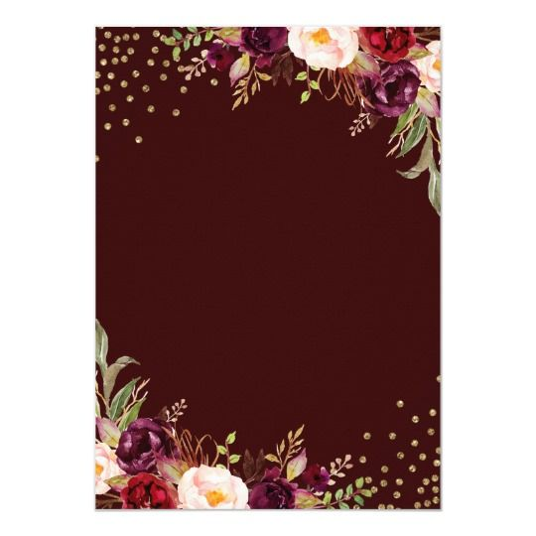

***Cultural Programs***

* **Siva Thandavam**
* **Buzzy Bees**
* **Dazzling Disc**
* **Magadheera Masquerade**
* **Adi Purush Theme**
* **Larkish Lezim Performance**
* **Goan Dance**
* **Surprise Dance**
* **Pyramids**
* **Plastic ban Theme**
* **Giggling Jokers**
* **Maharashtra Lavani**
* **Maa Tujhe Salaam**
* **Chayya Chayya**
* **Maguva _Teachers Theme**
* **Nani’s Gang Leader**
* **Dol Dol Dol**
* **Retro Dance**
* **Few Medley’s**

ANNUAL DAY AGENDA

* ***Welcoming the Guest***
* ***Welcome Song***
* ***Floral Greetings***
* ***Lighting of the Lam***
* ***Prayer Song***
* ***Annual Report***
* ***Prize Distribution***
* ***Address by the Distinguished Dignitaries***

